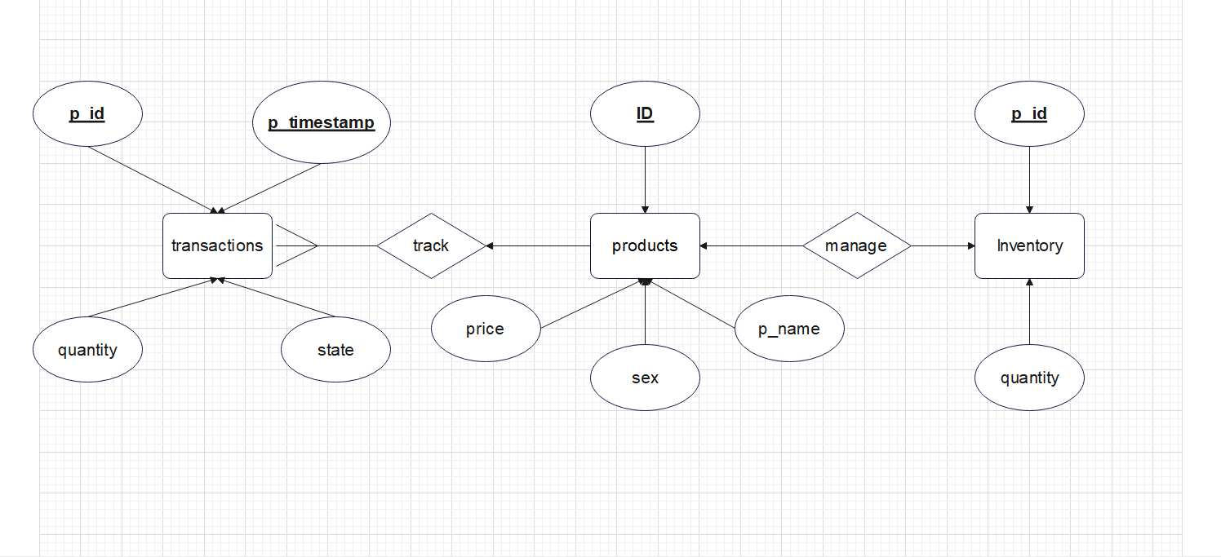Local

Inventory( p-id ,quantity)

Products(ID, p_name, sex ,price )

Transactions ( p-id ,p-timestamp ,quantity, state)

Replication

Inventory( p-id ,quantity)

Transactions ( p-id ,p-timestamp ,quantity, state)